CHOI Jang Hyeon

1155077214

Mentor: QI Sun

Term 2, 2020-21

March 1, 2021

FYP Progress Report: Week 8

The Titan Xp graphics card that I tested on a NCHW memory layout achieved an average of 1481.44 GFLOPS from 500 configuration trials:

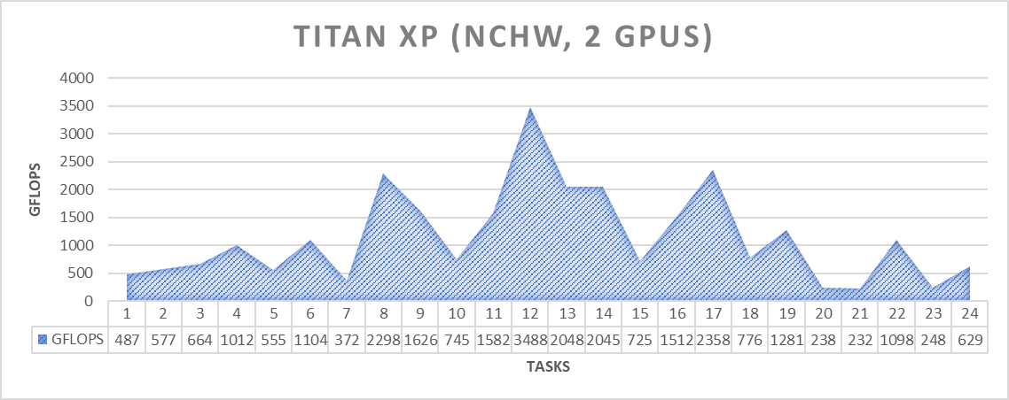

On the other hand, testing with the NVIDIA 1080Ti on the same memory layout achieved an average of 1345.92 GFLOPS with 1000 configuration trials (with 800 as early-stopping), which took 18 hours and 45 minutes. Although the GPU could achieve higher peaks under this setting, more testing needs to be done to determine whether the performance difference occurred due to the additional number of trials or hardware architecture. The graphics card needs to be tested under the NHWC format as well for a more comprehensive comparison. 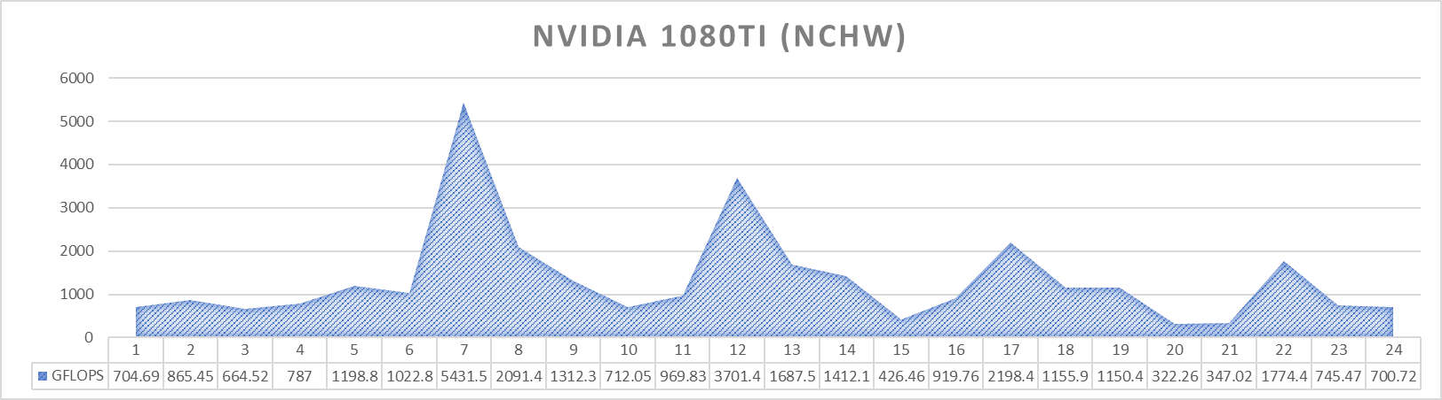

I now need to improve the algorithm such that it explores a larger solution space for optimal configuration before tuning.